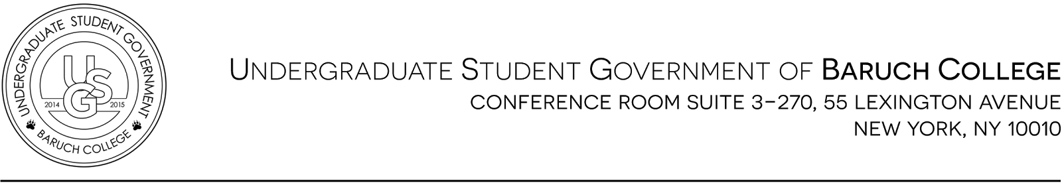
Meeting #13
Tuesday, December 1st, 2015
Meeting Start Time 5:31 PM
Meeting End Time 6:12 PM

Attendance

Annie Sourbis | President | Candice Chatterpaul | VP of Student Affairs
Nardine Salama | Executive VP | Nicole Zelenko | VP of Campus Affairs
Isabel Zhao | Treasurer | Andrew Armoogan | Representative Senator
Katy Yu | Executive Secretary | Alvin Daniel | Representative Senator (Late)
Sau Fong Lin | Chair of Inter-Club Affairs | Ehtasham Bhatti | Representative Senator (Absent)
Salma Mohamed | Chair of Finance | Joanne Beloy | Representative Senator
Agata Poniatowski | Chair of PR | Larry Biscette | Representative Senator
Ben Chatham | Chair of Appeals | Laura Martinez | Representative Senator
Selina Lee | Chair of Marketing | Rebecca Clabby | Representative Senator
Cherry Aung | VP of Academic Affairs | Sean Liu | Representative Senator
Daniel Dornbaum | VP of Legislative Affairs | Viral Shah | Representative Senator

Passing of the Minutes

- Minutes of Meeting #12 - Motion passes 12-3-1

Reports
- Executive Vice President | Nardine Salama
  - Bash - Meeting is rescheduled; will inform everyone about the next meeting
  - MVP - Congratulation to Viral Shah!
- Vice President of legislative affairs | Daniel Dornbaum
  - USS - This Sunday there is a meeting at the Guttman Community College. CUNYfirst does not display hybrid classes. Tomorrow USS is meeting during the middle day with Council Woman Inez Barron downtown to talk about the tuition freeze and further steps to take. Tomorrow night we will meet with the Chancellor about university wide policy/issues.
  - Community Reception with President - Tomorrow from 6-8PM in the Library building on the 7th floor
- Vice President of Student Services | Candice Chatterpaul
  - Dreaming American - This Thursday December 3rd from 6-9PM, please continue marketing. This is a very short film, about 20 minutes, that raises awareness on LGBT & Immigration right
  - USG Report - Reached 11 listeners yesterday. There will be a new schedule in the Spring Semester. If anyone is interested in joining the show, please reach out
- Vice President of Campus Affairs | Nicole Zelenko
  - Snow Much More Fun Marketing - Coming up next Thursday. They have an amazing flyer ready and the Facebook event is created. There will be a Christmas movie during club hours and the Snow Much Fun Event in MPR at night. Need volunteers to hand out flyers for this Thursday and Tuesday during club hours. She will send out an email about the breakdown and tasks.
  - Lisa Edwards - Will be coming in next meeting to talk about the 17th Lex renovation project. If you have any questions please reach out to her.
- Chair of Clubs and Organizations | Sau Fong Lin
  - Budget Rescissions - Reached out to inactive clubs that confirmed they are no longer active. Motion to rescind Student Parent Association ($1,000), Amnesty International ($1000), and Solution Across Border ($1,170). Motion passes 17-0-0.
  - Events Quota - 19/22 senators attended events this month. Not counting Eboard; Only 68% of senators attended. 3 senators did not meet the quota. Goal is to reach 100%.
- Representative Senator | Joanne Beloy
  - Secret Santa Exchange - Next week is the exchange at the end of the meeting
  - Club Appreciation Dinner - Location is 7th Floor on 1/28 6-8:30PM. 23 clubs RSVP. Hope we can get more clubs by Friday and reach out to them if they did not sign up. Theme is black, white, and gold. The invitation card will be delivered to club leaders in person.
Unfinished Business

  - ExStress Workshop - Please be on the lookout for an email about the data and location
  - Snow Much Fun - Need ugly sweater volunteers. Senate can participate, but they can’t win anything
  - Hot Chocolate Tabling - Next Tuesday and Thursday during club hours we need people to volunteer
  - SYS - Sau Fong is collecting donation money for WIB’s Fashion Show Event
  - Secret Santa between Clubs - 12/10 is the day of the exchange; this gift is for the whole club not pertain to any person
  - Hamburger Eating Contest - Golden Key’s Fundraiser Event; Dan is competing with Sean to raise money
  - USS Budget Hearing - Friday in the Bronx at 2pm at Hostos Community College, USS will be having a budget hearing. Sunday will be when the budget comes before the senate for passage.
  - Reform in Albany- Sheldon Silver who was a previous assembly speaker was recently convicted on corruption charges. This “cleaning up” of Albany will be great for the state hopefully the students of CUNY. We have seen a divestment from higher education by the state, and possibly with new leadership we will see some positive changes.
New Business

  - USG Boot Camp - Event is not confirmed; still working on a date that works for everyone
  - Welcome Week
  - Men’s Basketball Team - Friday the 11th, please come and show your school spirit!

Adjournment
  - Motion to adjourned Meeting #13 at 6:12 PM. Motion passes 17-0-0

